Exercise 1: *Providing a new project with necessary files.*

Follow the steps below:

1. Go to “Resources” folder on the CD. Copy the following images:

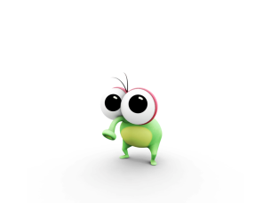

Phii.png



Phii2.png

1. Paste these images into your image resources folder for the Hello World program, which is in My Documents -> Visual Studio 2008 -> Projects -> HelloWorld -> HelloWorld -> Resources, i.e. C:\Documents and Settings\Name\My Documents\Visual Studio 2008\Projects\ HelloWorld\HelloWorld\Resources\Images.
2. Open your HelloWorld project in Visual Studio 2008.

* Open Visual Studio 2008
* 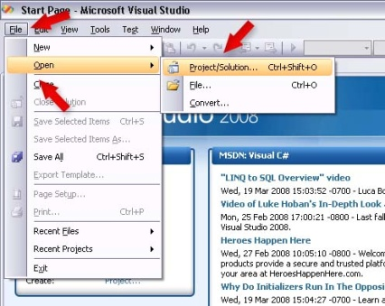Click File -> Open -> Project/Solution as showed in Figure 1.
* 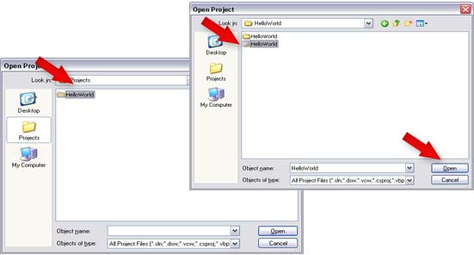Click “HelloWorld” -> “HelloWorld” -> Open Microsoft Visual Studio Solution as showed in Figure 2.

Figure 2

Figure 1

* Open GameLogic.vb and delete everything between SwinGame.Graphics.ClearScreen() and 'Refreshes the Screen and Processes Input Events (Figure 3).

|  |
| --- |
| Do  'Clears the Screen to Black  SwinGame.Graphics.ClearScreen()  'Draws red rectangle  Code to Graphics.FillRectangle(Color.Red, 20, 150, 500, 50)  delete  'Draws text "Hello World"  Text.DrawText("Hello World!", Color.Aqua, GameFont("ArialLarge"), 50, 50)  'Refreshes the Screen and Processes Input Events  Core.RefreshScreen()  Core.ProcessEvents()  Loop Until SwinGame.Core.WindowCloseRequested() = True |

**NOTE:** We provide you with all necessary images for these exercises. If you want to create your own images, you must make them as 32 bit PNG images. Moreover, you must consider that the size of the screen in SwinGame. It is 800x600 pixels, so pictures have to answer this parameter.

Exercise 2: *Loading images into your program*

Follow the steps below:

1. From Solution Explorer open GameResources.vb.
2. Scroll down to the LoadImages() sub.
3. Add the following code to LoadImages() sub:

|  |
| --- |
| …  NewImage("phii", "phii.png")  NewImage("phii2", "phii2.png")  … |

Write the complete code for LoadImages() sub into a worksheet.

1. Why do we need the first parameter in NewImage()? (write your answer to a worksheet)

Exercise 3: *Drawing the background*

Follow the steps below:

1. Open GameLogic.vb from Solution Explorer.
2. Put the following code inside the game loop, right after Do statement:

|  |
| --- |
| …  Graphics.DrawBitmap(GameImage("phii"), 0, 0)  … |

1. Press the "StartDebugging" button at the top of the screen (looks like a green arrow arrow.jpg, F5 works too) to see changes.
2. What do you think DrawBitmap() sub does?

**NOTE:** The phii.png image size is 800x600 pixels which is same with the size of the Swingame Screen. Also, spelling of the image name is Case sensitive, make sure that you spelled it correctly when you are referencing to it.

Exercise 4: *Drawing other images on the screen*

Make the following changes to your program:

1. Tell the computer to draw phii2.png on the screen. Put the solution into the worksheet.

*Hints:* In order to put another image on the screen, use DrawBitmap() as in previous exercise, but change the position of the image from (0, 0) to custom one.

**NOTE:** You can put DrawBitmap() sub calls in certain order to have different results. For example, if you want to draw image2 on top of image1, you should use DrawBitmap(image1, posX, posY) before drawing image2. Try to play around to see the difference.

Exercise 5: *Loading fonts*

Follow the steps below and put the solution into the worksheet:

1. Copy the BEANTOWN.ttf font from the Resources folder on the CD and paste it into Fonts folder in your project (see exercise 1).
2. Open GameResources.vb, find the LoadFonts() sub and put the following code in it:

|  |
| --- |
| …  NewFont("BeanTown", "BEANTOWN.ttf", 80)  … |

Write the completed LoadFonts() sub into the worksheet.

**NOTE:** We provide only one true type font for this exercise, if you want to use another one, you could download it from <http://www.1001freefonts.com/> for free.

Exercise 6: Drawing the text by using loaded true type font

Follow the steps below and write the solution into the worksheet:

1. Open GameLogic.vb from the Solution Explorer.
2. Use Text.DrawText("Text to draw", Color.(Green), GameFont("BeanTown"), posX, posY).
3. Write the code that tells the computer to draw text with a new font to the worksheet.